**Name:** abeer osama Youssef abd el aziz

**B.N:** 506

**Date**: 2/6/2020

**Topic:** Mobile Computing

**Github link:** <https://github.com/abeer-osama/Mobile-Computing->

**Github page:** <https://abeer-osama.github.io/Mobile-Computing-/>.

**Application brief:**

Mobile computing is the field of wireless communication and carry-around computers, such as laptop computers. In some ways the mobile computing field spun out of work initialized within the ubiquitous computing area. Likewise, the early focus on wireless networking led to wireless communication mechanism research. Work on these mechanisms began in the mid-1980s and led up to the standards around wireless [local area networks](https://www.sciencedirect.com/topics/computer-science/local-area-networks) (WiFi) that started forming in the late 1990s.

**Some applications:**

The applications of mobile computing today have become ubiquitous and pervasive in business, consumer, industrial, entertainment and many specialized vertical-market activities. [Desktop, or nonmobile, computers](https://searchenterprisedesktop.techtarget.com/definition/desktop-computer) allow for a higher degree of hardware configurability or higher computational performance, but a mobile computing device is the vehicle of choice for almost every end user today. The key advantage of mobile computing is convenience, allowing users anytime, anywhere access to information and computational resources.

**Screenshots:**

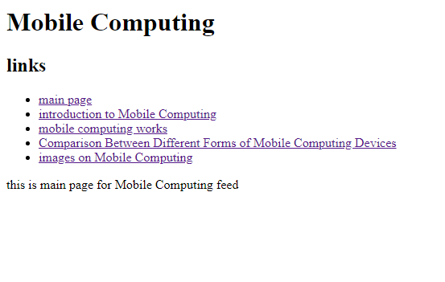

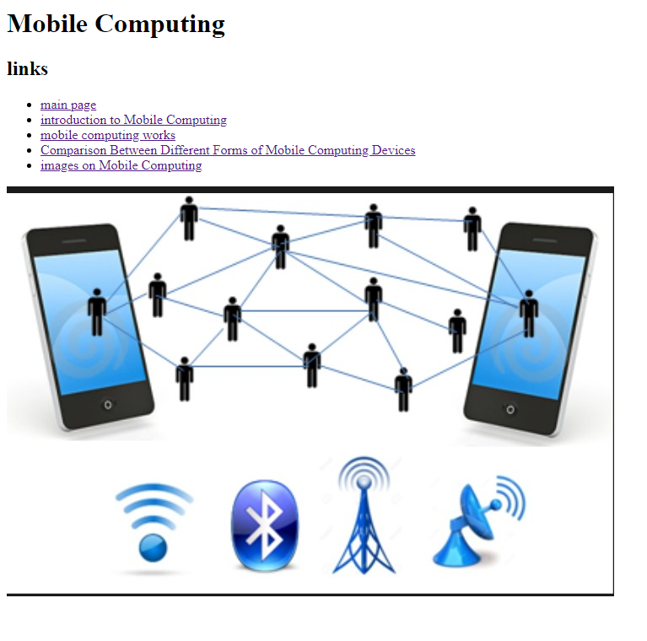**source code:**

